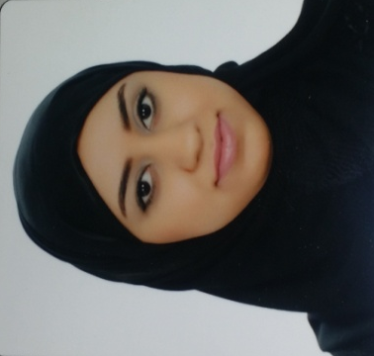  MY GOAL  My goal is to keep improvement in all situation to provide service with high quality.  skills  1-work in all Microsoft programs.  2-speking, writing and reading Arabic perfect.  3-speking, writing and reading in English very good. | EXPERIANCE  AL IIHSAN / KINDERGARTEN / TWO YEARS  I worked in kindergarten as English teacher. In addition, my responsibility was explaining the topic for the children in easy way.  WALNUT WARRANTY AUTHORITY / INPUT DATA / ONE MONTH  My responsibility was input the information of the student in the system. In addition, I was organizing the exam papers.  GENERAL ORGANIZATION FOR YOUTH & SPORTS / TOW MONTH  My responsibility was to input he information in the system and connecting with the members in sport clubs.  ORGANIZING THE EIGHTH FORUM BUSINESS ADMINSTRATION  I participate in EIGHTH FORUM BUSINESS ADMINSTRATION as organizer.  EDUCATION  UNIVERSITY OF BAHRAIN/ BACHELOR / 2015  I had graduated from university of Bahrain, and I have bachelor certificate in business administration.  almarefa secodary school for girs / 2010  I have certificate of secondary school from Almaarifa school in 2010.
  MARWA ALI ALI SAAD
  BAHRAINI / MARRID / 920306560 / THE PLACE OF LIVING IS HAMAD TOWN/ 34538435 / MARWA.UOB75@GMAIL.COM

