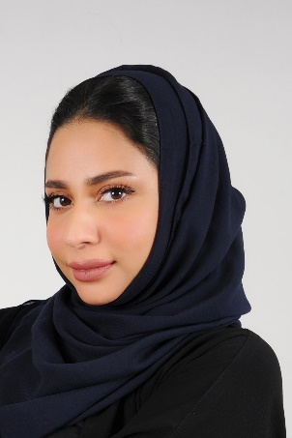
Personal information :

Name : Mariam Khalil Khalifa Buallay
Date of birth :22 – March-1995
Nationality : Bahraini
sex: female
Age :24
CPR: 950306673
Phone number : 66333952 - 39305080
Email : Mariam-buallay@hotmail.com
Marital Status : Single

Education
- Graduated from AMA international university – business informatics
-Hamed Town secondary school
-Bahrain Institute for Entrepreneurship and Technology
-Internship on job training in Land registration & Follow – Up Directorate Survey & Land Registration

Experienc
Work experience :
- customer service – dealing with passengers
- worked as a visa checker
- change booking
- check in counters
- customer care training
- visa checking training
- customer service training

Other experience :
- booking orders for advertisement
- communicate with other companies
- certificate & emails
- emails
- using all Microsoft programs
- handling billing – cost estimates

Skills:
- Active at work
Team work skills -
Communication skills -
-Good marketing skills
Friendly -
Presentable -
-Organized
Time management

Details:
Languages :Arabic & English ( speaking , reading , writing )
My interest is film making , photographer , teaching English

