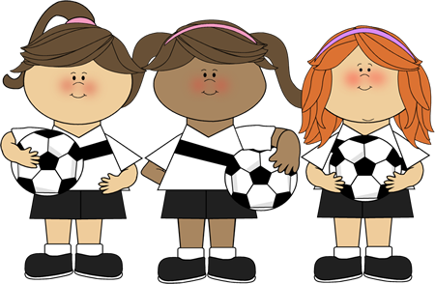




AFFIRMATIVE | NEGATIVE | QUESTIONS
I played football. | I didn’t play football. | Did I play football?
You played football. | You didn’t play football. | Did you play football?
He played football. | He didn’t play football. | Did he play football?
She played football. | She didn’t play football. | Did she play football?
It played with a ball. | It didn’t play with a ball. | Did it play with a ball?
We played football. | We didn’t play football. | Did we play football?
You played football | You didn’t play football. | Did you play football?
They played football. | They didn’t play football. | Did they play football?





Usage:

1. To describe a scene in the past- where things were happening
2. An interrupted action- with the word when in the other sentence
3. Two actions happening at the same time- with the word while



Usage:

1. Past events at a specific time
2. Repeated events in the past.
3. Telling a story about the past.

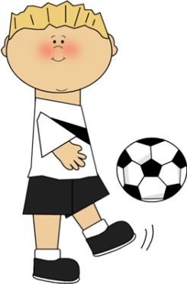

Time Words:

1. when
2. while
3. all evening/week/day
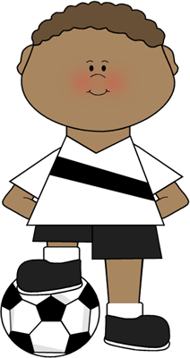

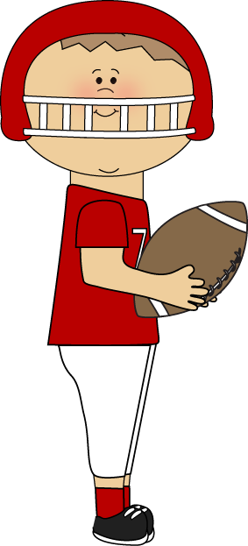
Time Words:

1. last week/year/month
2. last night
3. yesterday
4. ago/ 3 years ago
5. in 1998
6. after when




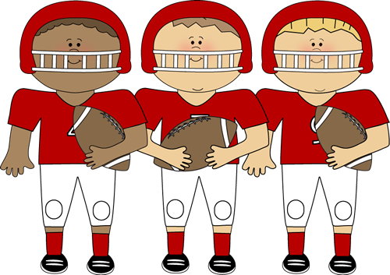
AFFIRMATIVE | NEGATIVE | QUESTIONS
I was playing. | I wasn’t playing. | Was I playing?
You were playing. | You weren’t playing. | Were you playing?
He was playing. | He wasn’t playing. | Was he playing?
She was playing. | She wasn’t playing. | Was she playing?
It was playing. | It wasn’t playing. | Was it playing?
We were playing. | We weren’t playing. | Were we playing?
You were playing. | You weren’t playing. | Were you playing?
They were playing. | They weren’t playing. | Were they playing?

