
AlFalah Schools
A’Ali – Boys
English Department
Grade Eight

Listening Activity 1
Second semester 2018-2019
Class: ……………………………..
Name: …………………………………………………………

- Listening:
A- You will hear a radio programme about safety during floods. Read the leaflet and guess the missing words. Listen and complete it.
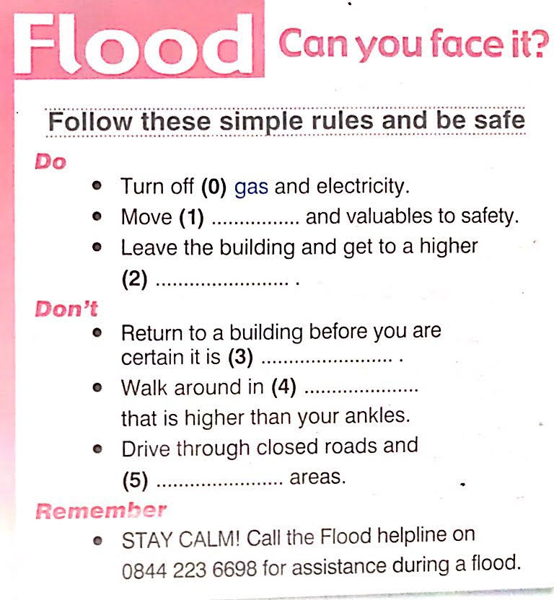

AlFalah Schools
A’Ali – Boys
English Department
Grade Eight
Writing Activity 1
Second semester 2018-2019
Class: ……………………………..
Name: …………………………………………………………

- Writing
(Dairy entries)
- Imagine you’ve experienced a flood. Use the information from Ex.7, P.46(SB) to write two short diary entries. Write:
- When it happened ● What happened
- What you did ● How you felt
……………………………………………………………………………………………………..……………………………………………………………………………………………………..……………………………………………………………………………………………………..
……………………………………………………………………………………………………..……………………………………………………………………………………………………..……………………………………………………………………………………………………..
……………………………………………………………………………………………………..……………………………………………………………………………………………………..……………………………………………………………………………………………………..
……………………………………………………………………………………………………..……………………………………………………………………………………………………..

