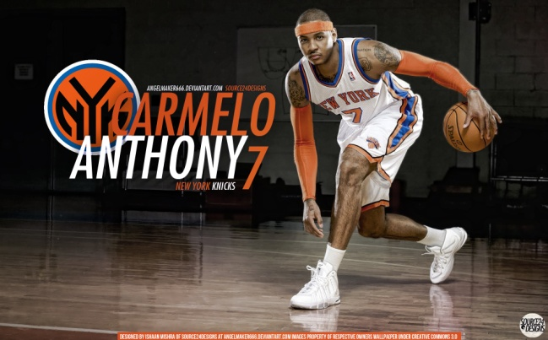
WRITE THE CORRECT VERB

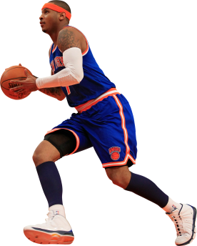
1. When Carmelo Anthony __________ (shoot) a buzzer beater, the crowd ____________(yell) loudly.

2. The New York Knicks _________ (win) the championship in 1970 and in 1973, but they ____________ (not/win) another championship after that.

3. While LeBron James ____________ (shoot) a free throw, some of the fans from the other team ___________ (boo) .That _________ (be) very rude of them.

4. James Naismith _______________ (invent) basketball in 1891. He _________ (use) a peach basket as the basket. You ________ (have) to stop after every shot and remove the ball from the basket. Finally they _______(cut) a hole in the bottom.

5.While I ____________ (watch) the Lakers game on TV, I __________ (eat) a big bowl of popcorn.

6. ________ you ________ (see) The NBA Top 10 Plays of the Day on YouTube? Derrick Rose ________ (block) a shot by Kobe Bryant. It ______ (be) the game winner!

Select the correct tense

1. While Blake Griffin ____________ toward the basket, his teammates ________ next to him.
a. was dribbling/were running
b. dribbled/ran
c. didn’t dribble/didn’t run

2. Kevin Durant ___________ his foot and ________ play in tonight’s game.
a. was fracturing/couldn’t
b. fractured/couldn’t
c. were fracturing/could

3. Michael Jordan _________ 32,202 points in his NBA career.
a. did score
b. was scoring
c. scored

4. The San Antonio Spurs ________ the NBA championship in 2014- they __________ win in 2013- the Miami Heat did.
a. was winning/wasn’t winning
b. won/didn’t win
c. did win/were winning

5. When Giannis Antentokoumpo
_________ in the US, many fans _________ for him at the airport.
a. arrived/were waiting
b. was arriving/waited
c. arrived/waited

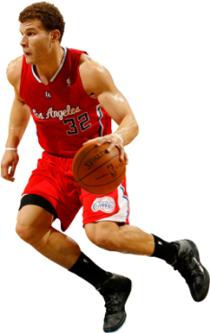

Tick the past simple tense

1. _____ What did your sneakers cost?
2. _____ Did he catch the ball?
3. _____ Blake Griffin was running fast when…
4. _____ While the team was flying to L.A.,
5. _____ Abdul-Jabbar broke the scoring record.
6. _____ Shaquille didn’t make the free throw.
7. _____ Wasn’t the referee looking, when
8. _____The captain was standing near the coach…
9. _____ I paid 50 Euros for my new uniform.
10. ____ Last night the ball hit the rim 20 times!

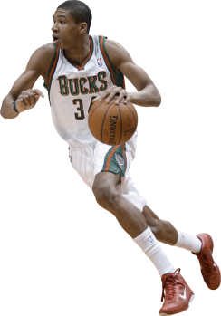

Select the correct tense

1. While Blake Griffin ____________ toward the basket, his teammates ________ next to him.
a. was dribbling/were running
b. dribbled/ran
c. didn’t dribble/didn’t run

2. Kevin Durant ___________ his foot and ________ play in tonight’s game.
a. was fracturing/couldn’t
b. fractured/couldn’t
c. were fracturing/could

3. Michael Jordan _________ 32,202 points in his NBA career.
a. did score
b. was scoring
c. scored

4. The San Antonio Spurs ________ the NBA championship in 2014- they __________ win in 2013- the Miami Heat did.
a. was winning/wasn’t winning
b. won/didn’t win
c. did win/were winning

5. When Giannis Antentokoumpo _________ in the US, many fans _________ for him at the airport.
a. arrived/were waiting
b. was arriving/waited
c. arrived/waited

KEY
1. When Carmelo Anthony made (shoot) a buzzer beater, the crowd was cheering (cheer) for hours!

2. The New York Knicks won (win) the championship in 1970 and 1973 but they didn’t win (not/win) another championship after that.

3. While LeBron James was shooting (shoot) a free throw, some of the fans from the other team were booing (boo).That was (be) very rude of them.

4. James Naismith invented (invent) basketball in 1891. He used (use) a peach basket as the basket. You had (have) to stop after every shot and remove the ball from the basket.

5.While I was watching (watch) the Lakers game on TV, I was eating (eat) a big bowl of popcorn.

6. Did you see (see) The NBA Top 10 Plays of the Day on YouTube? Derrick Rose blocked (block) a shot by Kobe Bryant. It was (be) the game winner!
Tick the past simple tense

1. √ What did your sneakers cost?
2. √ Did he catch the ball?
3. _____ Blake Griffin was running fast when…
4. _____ While the team was flying to L.A.,
5 √ Abdul-Jabbar broke the scoring record.
6. √ Shaquille didn’t make the free throw.
7. _____ Wasn’t the referee looking, when
8. _____The captain was standing near the coach…
9. √ I paid 50 Euros for my new uniform.
10. √ Last night the ball hit the rim 20 times!

