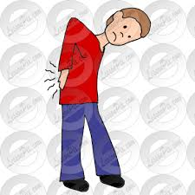
- Choose the correct answer.
  - Ali hurt his ……………….. while he was playing tennis.
hand – back - shoulder
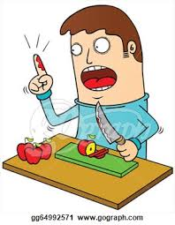
  - Ahmed ………………… his finger while he was cutting apples.
cut – broke - twisted
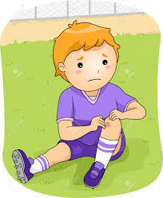

  - Salem broke his ………………….. while he was eating sweets.
back – arm - tooth
  - Yousif …………………………………… while he was riding his bike.
grazed his knee – twisted his ankle
- Read the following sentences and put (T) for true or (F) for false.
  - Julie has had the best day in her life. ( )
  - She hurt her back while she was cleaning the upstairs windows. ( )
  - She scalded her hand while she was
hanging a picture. ( )
  - Amy is going to make the dinner. ( )
Homework
Write (3) sentences about what accidents happened to you during your life.
- ………………………………………………………………………………………………………………………………………………………………………………………………………………
- ………………………………………………………………………………………………………………………………………………………………………………………………………………
- ……………………………………………………………………………………………………………………………………………………………………..……………………………………….

