
- Complete the following sentences.
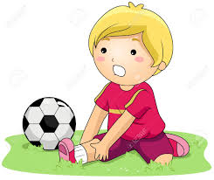
  - Sara ………………………………………………….. while she was cutting the paper.
  - Ahmed ……………………………………………….. while he was playing football.
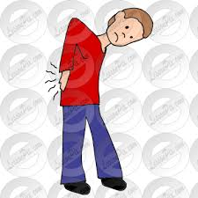
  - Salem ……………………………………………….. while he was walking fast.

  - Yousif ……………………………………………….. while he was eating.
- Answer the following questions.
  - What happened to Julie while she was cleaning?
………………………………………………………………………………………………………………………………
  - When did Julie hit her finger?
………………………………………………………………………………………………………………………………
  - Where are the girls going to eat?
…………………………………………………………………………………………………………………………………..
Homework
Write a paragraph about what accidents happened to you during your life.
………………………………………………………………………………………………………………
………………………………………………………………………………………………………………
………………………………………………………………………………………………………………
………………………………………………………………………………………………………………
………………………………………………………………………………………………………………
………………………………………………………………………………………………………………

