Describe the picture and speculate about the people. 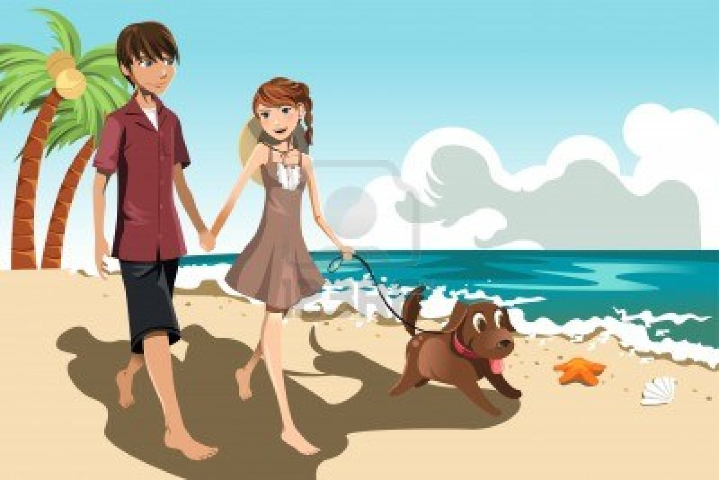
- Who are the people in the picture? ......................................................................................................................................................................................................................................................................................................................
- Where are they from?
......................................................................................................................................................................................................................................................................................................................
- What are they wearing?
......................................................................................................................................................................................................................................................................................................................
- Where are they now?
......................................................................................................................................................................................................................................................................................................................
- What are they doing?
......................................................................................................................................................................................................................................................................................................................
- What are they talking about?
......................................................................................................................................................................................................................................................................................................................
- What are they going to do next?
......................................................................................................................................................................................................................................................................................................................
- What’s the weather like?
……………………………………………………………………………………………………………………………………………………………………………………………………………………………………………...............................................................

