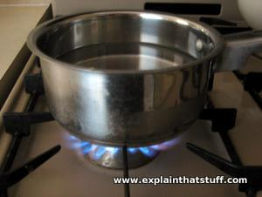
0 and 1st conditionals
Which of these statements are (A) always true or (P) possibly true?
- When you heat water, it boils. (.......)
- If you don’t exercise, you might put on weight. (.......)
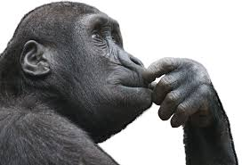
- When you leave chocolate in the sun, it melts. (.......)
- Unless study, you won’t pass your exams. (.......)
- If it’s sunny next weekend, I’ll go to their beach. (.......)
- You can’t eat pasta if you don’t cook it in liquid. (.......)
Choose the correct option from the words in italics
- We use the 0 conditional for things that are (always true/likely) to be true
- We use the 1st conditional for things that are (always true/likely) to be true
Look at the form of these conditional sentences.
They all have 2 clauses, the main (conditional) clause and the result clause.
When you heat water, it boils.
- The main (conditional) clause begins with:
if, ……………………, or ……………………

- form of 0 conditional:
Result clause
Condition clause

-if etc. + present simple, …………………………..

form of 1st conditional
Result clause
Condition clause

-if etc. + present simple, subj. + ……………………...…………….

