
What’s the matter?

headache, toothache, cough, broken leg, backache, stomachache, runny nose, sore throat, bleeding nose, cut on finger, cold, high temperature

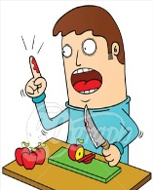
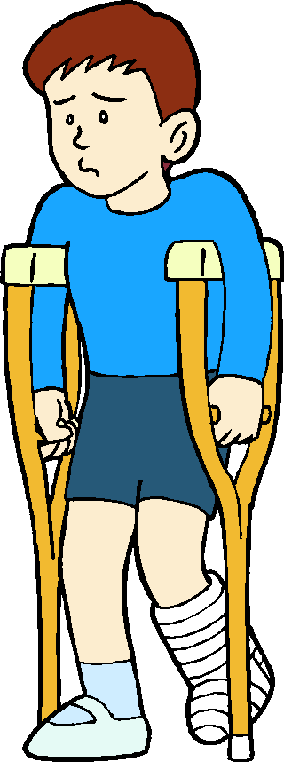
- What’s the matter?
- I’ve got a ___________________.
-You should ___________________
_________________________________
- What’s the matter?
- I’ve got a ___________________.
-You should ___________________
_________________________________


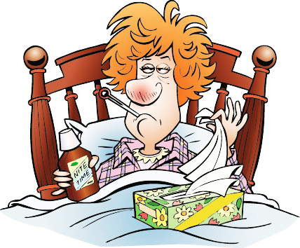
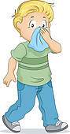
- What’s the matter?
- I’ve got a ___________________.
-You should ___________________
_________________________________
- What’s the matter?
- I’ve got a ___________________.
-You should ___________________
_________________________________

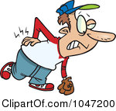
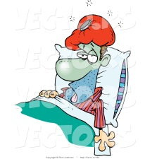
- What’s the matter?
- I’ve got a ___________________.
-You should ___________________
_________________________________
- What’s the matter?
- I’ve got a ___________________.
-You should ___________________
_________________________________

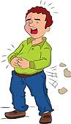
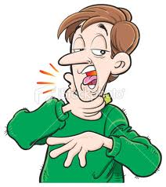
- What’s the matter?
- I’ve got a ___________________.
-You should ___________________
_________________________________
- What’s the matter?
- I’ve got a ___________________.
-You should ___________________
_________________________________

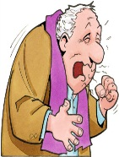
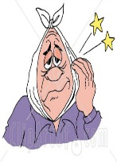
- What’s the matter?
- I’ve got a ___________________.
-You should ___________________
_________________________________
- What’s the matter?
- I’ve got a ___________________.
-You should ___________________
_________________________________

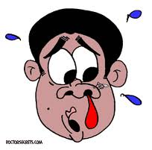
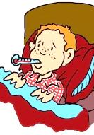
- What’s the matter?
- I’ve got a ___________________.
-You should ___________________
_________________________________
- What’s the matter?
- I’ve got a ___________________.
-You should ___________________
_________________________________

put ice on the nose, eat healthy food, visit a dentist, take an aspirin, put a cast (наложить гипс), use a nose spray, wear a bandage , visit a doctor, use a plaster, drink hot milk, take vitamins, cold, put warming up cream

